**HEATING CYCLE 1**

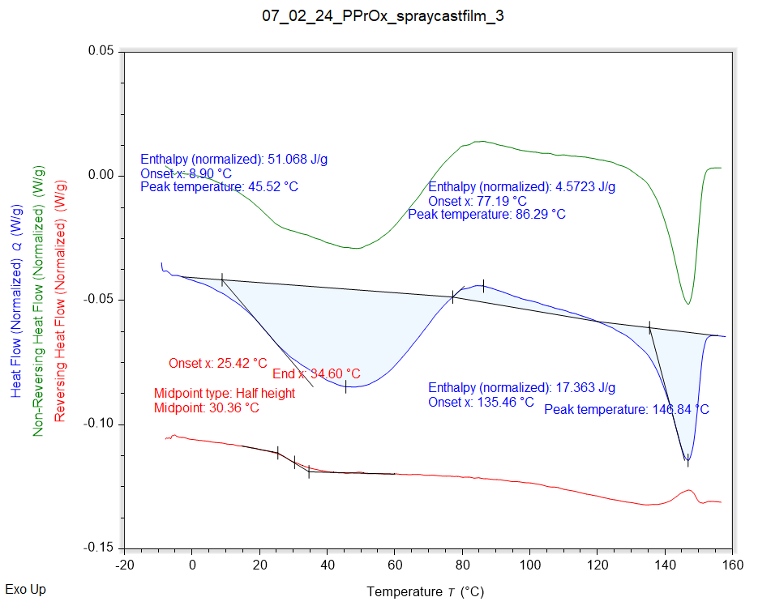

|  |  |  |  |
| --- | --- | --- | --- |
| Solvent HC1 | Peak Onset | Peak Location | Enthalpy |
|  | 8.899 °C | 45.524 °C | 51.068 J/g |

|  |  |  |
| --- | --- | --- |
| Recrystallisation HC1 | Peak Onset | Peak Location |
|  | 77.188 °C | 86.294 °C |

|  |  |  |  |
| --- | --- | --- | --- |
| Melting HC1 | Peak Onset | Peak Location | Enthalpy |
|  | 135.459 °C | 146.841 °C | 17.363 J/g |

|  |  |
| --- | --- |
| Tg HC1 | Onset |
|  | 25.419 °C |